NATIONAL SUPER AND BROODBOX ASSEMBLY JIG
D & E 0mm long x 60mm deep x 18mm wide

D & E 0mm long x 60mm deep x 18mm wide

C B 2 x 420mm long x 60mm deep x 18mm wide

B B 2 x 420mm long x 60mm deep x 18mm wide

C B 2 x 420mm long x 60mm deep x 18mm wide

B B 2 x 420mm long x 60mm deep x 18mm wide

A B 2 x 420mm long x 60mm deep x 18mm wide

40mm
20mm

A

Cutting List
A 1 x 460mm x 460mm x 9mm Ply
B 2 x 420mm long x 60mm deep x 18mm wide
C 2 x 380mm long x 60mm deep x 18mm wide
D 2 x 420mm long x 17mm deep x 18mm wide (For use with metal / plastic runners)
E 2 x 420mm long x 11mm deep x 18mm wide (for use with castellated spacers)

Below is finished jig
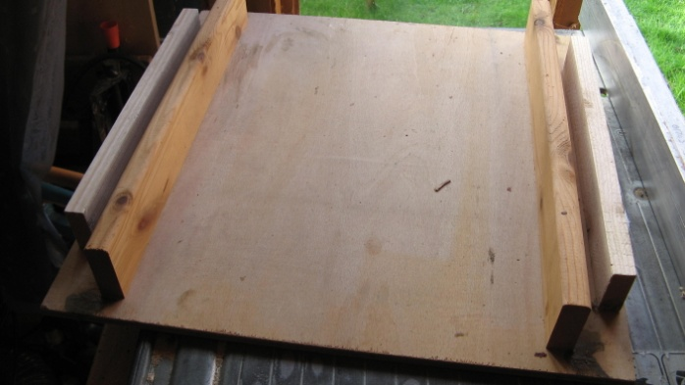
Spacers placed between the fixed sides of the jig to give correct hight for sides. 11mm if you are using castellated spacers and 17mm for runners.
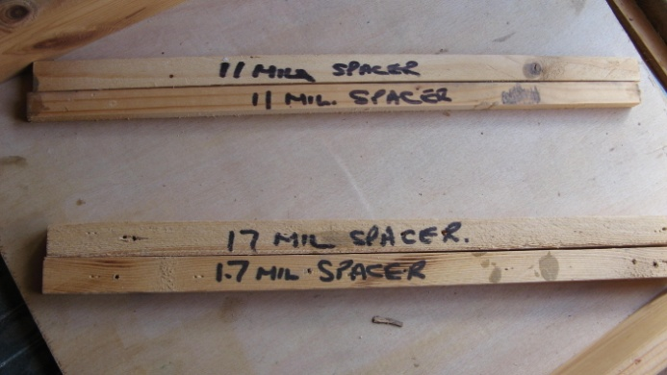
Template for drill holes if screwing, this is not required if you are using the nails provided.
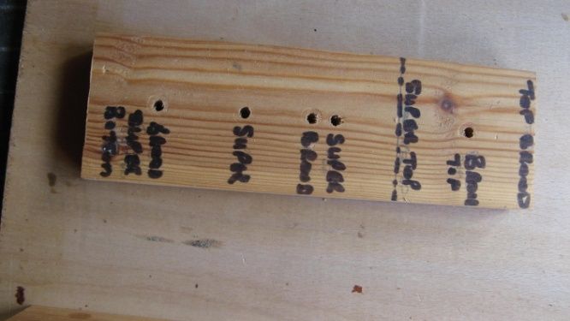
Template for drill holes in top and bottom bars if screwing, this is not required if you are using the nails provided.
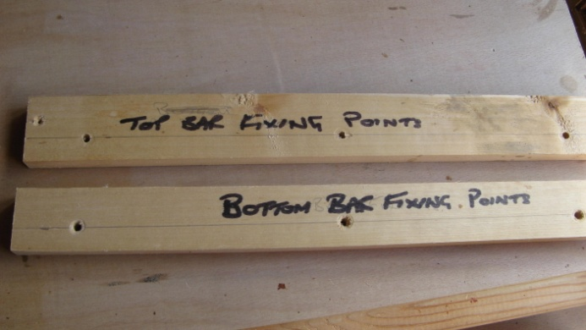
Using a template drill the two end pieces then countersink the holes.
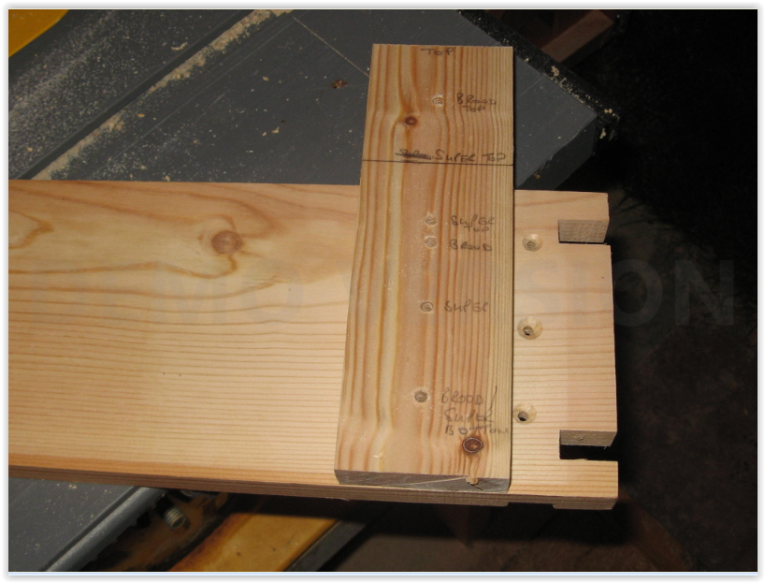
Place Super/Brood box side walls onto the raised strips and place the end on the floor of jig.
If you fit the runners first use the 11mm strips, if not use the 17mm strips.
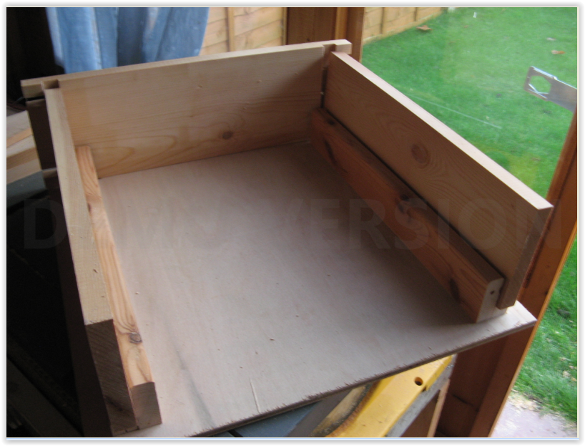
Glue the joints and then clamp the ends, ensuring the sides fit into the grooves in the end pieces, then screw together with 3 size 8x1½" screws each end. The support strips in the jig ensure the box is square.
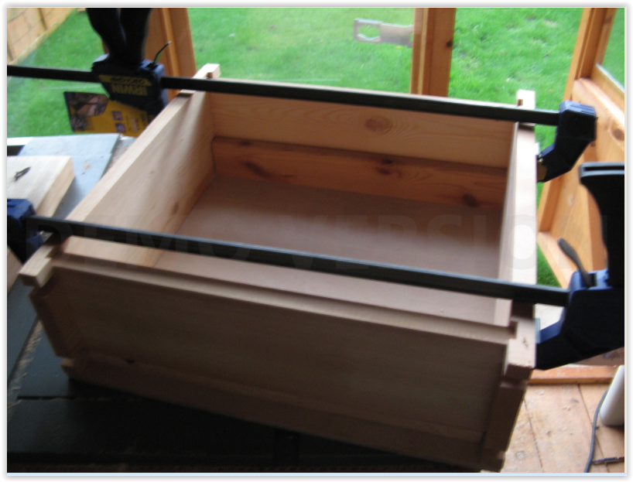
Using a template drill and countersink the holes for the top and bottom bars.
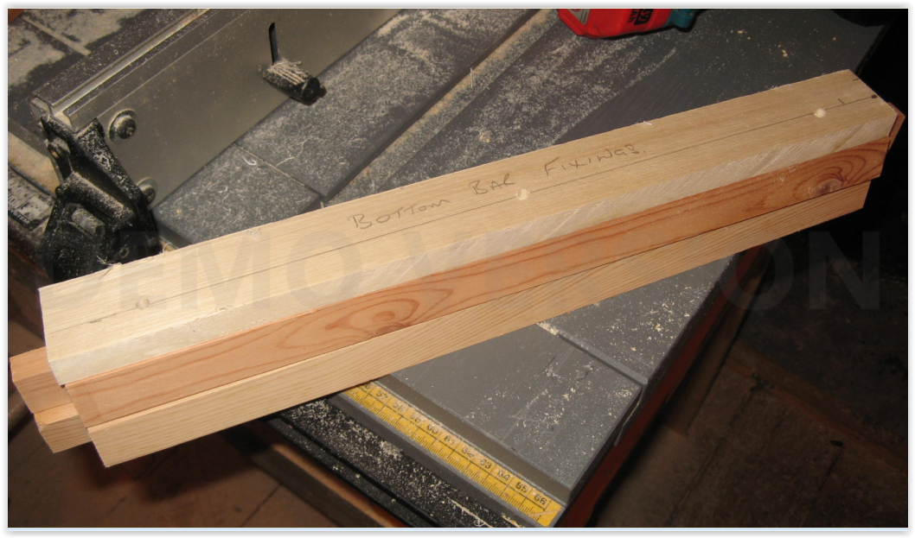
Fit top and bottom bars to the box, gluing joints and screwing.
For brood boxes fit runners and for supers fit runners or castellated spacers and you are finished.

